**Project 1: Planning Document**

**Team 7**

**Pratik Shringarpure**

**Yiyan Wang**

**Ollyting Xin**

**What tool you are planning to use and why**

The tool we plan to use is Unity and the reasons are as follows. Firstly, most of us are familiar with Unity as we have used it before for academic as well as personal projects. Secondly, unity is a useful and powerful tool to develop games and is commonly used in the game industry.

**A description of the environment you plan to create. Include a diagram of the environment.**

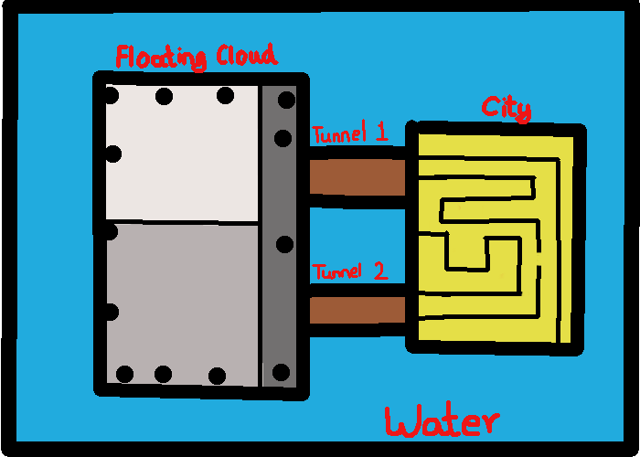

We are planning to create an environment which not only has separated parts, but also different styled parts. One of the parts is a busy city consisting of tall buildings, several roads and some entertainment facilities. All these objects in the city construct a complex maze which becomes a huge obstacle for characters in the city part. The unit player must find the way to another part through the huge maze. The size of city part is 200*80. Next to the city, there’s a water part which is 200*120. The other important part is above the water, floating at about 50 units scale high. The floating area is almost white, cloud-like objects, having the same size of the city part. There are many tiny holes all over the floating part. Although these holes are small, but all of them are bigger than one-unit scale which is enough for the unit player to drop down to the water part. There are also many other types of obstacles in the floating part. There’ll have cloud-like trees, cloud-like hills and cloud-like rocks. There are two tunnels connecting the city part and the floating part. The unit player can pass through these tunnels to travel from one part to another. The maze drawn in the image is temporary. The different shades of white in the image are used to depict the different heights of the terrain, where darker shade depicts low ground and lighter shade depicts high ground. The black dots represent the holes through which the unit might fall out of.

**Describe how the work is going to be broken up by the team. Team organization is up to your group, but assigning roles often works well. (“Team Lead”, “Designer”, “Programmer”)**. Note that everyone is expected to contribute code, not just design something and sit back while others do the rest of the work.

Shringapure is Team Lead, Wang is Programmer, Xin is Designer. We break our work into several parts, two main walkable parts, a water part and connectors (what the tunnel-like connects will exactly be haven't been decided yet). Wang will be responsible for the city part, Xin will do the cloud terrain and Shringapure will do the connectors. Besides, the movement of unit will be implemented by Wang. Codes related to the connector and camera will be implemented by Shringapure. GUI will be coded by Xin. The document is written by all of us together.

**There must be a set of instructions for using the environment. In this case, how to start the tool you are using and getting environment to appear, describing the camera controls and how to move the unit around on the screen should be sufficient. You should assume I am unfamiliar with the game development environment you are using (Unity, Unreal, etc.).**

As we use Unity game engine to build our game. Press the play button in Unity can get the whole environment appear. The unit player is set on to the city part. As game begins, the player will generate at a certain position in the city part. We have two different camera views in our game environment. The unit player connected with a third person camera which can zoom in and out by using mouse to observe the sufficient portion of surroundings. Different views of camera can be changed by pressing button C to shift from the perspective to isometric. The unit player can be controlled by keyboard buttons WASD and space for movement. There’ll be a detailed instruction of keyboard button control on GUI.